HABITS OF A MULTIPLYING DISCIPLE: ASSEMBLE

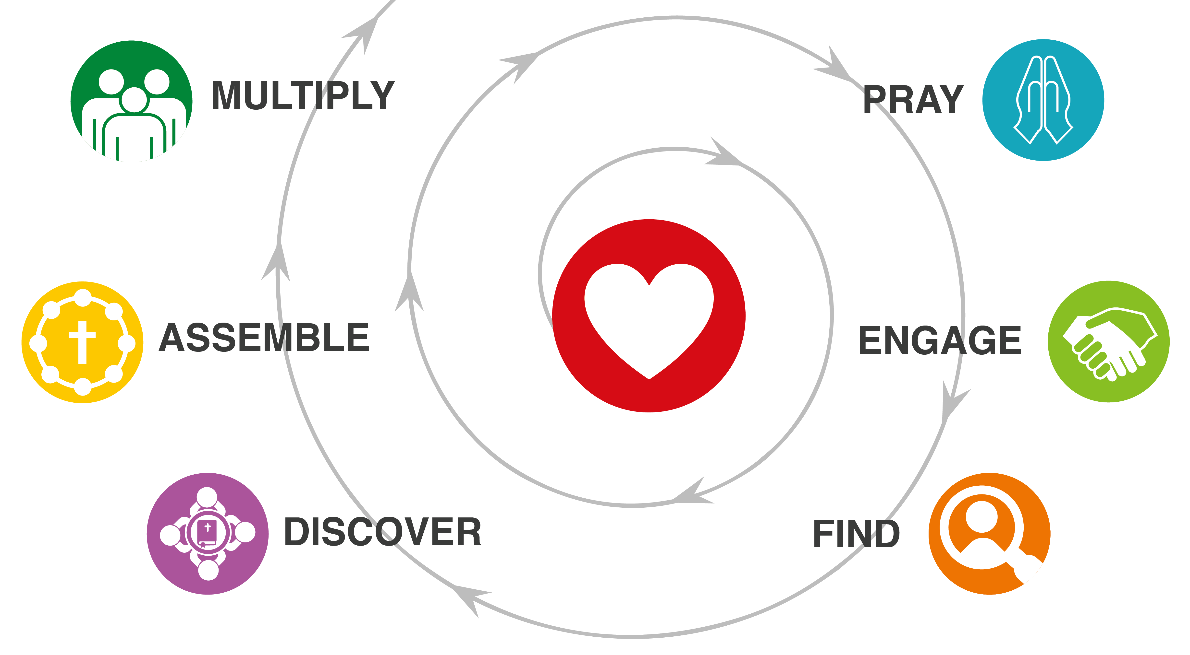
WHAT IS CHURCH?
What is the very first thing that comes to your mind when you hear the word “church”?
- There are many unexamined concepts of “church” in our minds.
- Which ones are biblical? Which ones are not? That is our focus in this lesson.

HOMEWORK DISCUSSION
How did it go leading a Discovery Group?
- Together discuss Acts 4:38-47.
- What stood out to you from this story?
- What did God invite you to do? (Your “I will…”) How did it go?
Based on this passage, make a list of characteristics and practices of a church.

DEFINING “CHURCH”
Based on this passage, list the characteristics and practices of a church.

What might be a simple, Biblical definition of “church”?

What are some contrasts between a typical church today and the Acts 2 church?

WHO ARE YOU CALLED TO REACH?
Do you currently have a clear sense of who God is calling you to reach?
- Who are they?
- What is their worldview?
- What is their daily rhythm?
What are you currently doing to engage or disciple them?
What have you or are you going to stop, start, or change to make disciple makers among them?
What is your key “win” for this week?

YOUR ASSIGNMENT
- Do a 3-Column Study on Mark 1:16-20.
- Pray. Then write out your answers to these questions using the 90-day action worksheet.
- Who are you called to reach?
- Who is or might be working with you to reach them?
- Make a 90-day plan to grow in God’s heart and the 6 habits.

What does it say?
(Write the text word-for-word.)

What does it mean?
(Write it in my own words.)

What must I do to obey?
(My “I will…” statement.)

With whom will I share?

90-Day Disciple-Making Plan
Take some time to pray and bring yourself to God. Then ask him for his direction as you work on this 90-day disciple-making plan.

Who are you called to reach?

Who is or might be working with you to reach them? Take some more time to pray and listen to God as you answer this.

How many Discovery Groups would you like to see begun in the next 90 days?

Pick 2 growth areas in each column. Then write out your plans to grow yourself and your team in those areas. These are tentative plans that you will refine in collaboration with your teammates. Feel free to use more paper, if needed!

Growth Area | Days 1-30 | Days 31-60 | Days 61-90
God’s Heart
Pray
Engage
Find
Discover
Assemble
Multiply

Day 1-30 Tentative Plan

Day 31-60 Tentative Plan

Day 61-90 Tentative Plan

What will you do in the next 48 hours to begin implementing your plan?

